

EE 386 Lab 2

Fast Fourier Transform, Magnitude, Phase and Modulation

By. Christopher W. Fingers

010099178

**Part 1:**

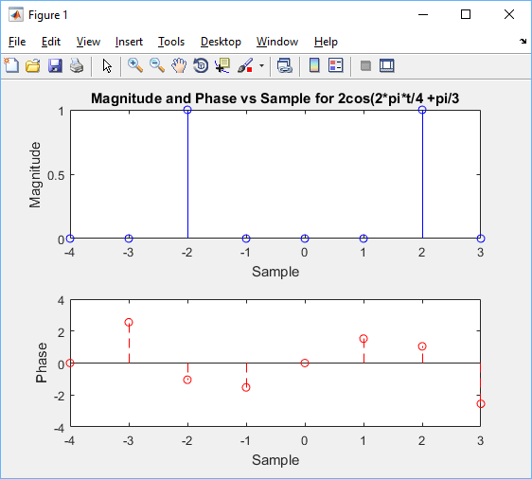

**Figure 1: Frequency domain for the function s = 2*cos(2*pi*t/4 +pi/3)**

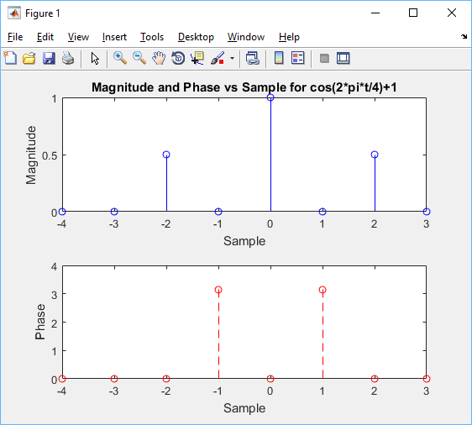

**Figure 2: Frequency domain for the function s = cos(2*pi*t/4)+1**

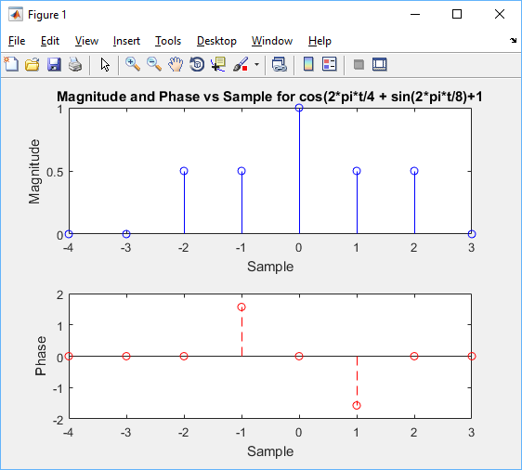

**Figure 3: Frequency domain for the function s=cos(2*pi*t/4) + sin(2*pi*t/8)+1**

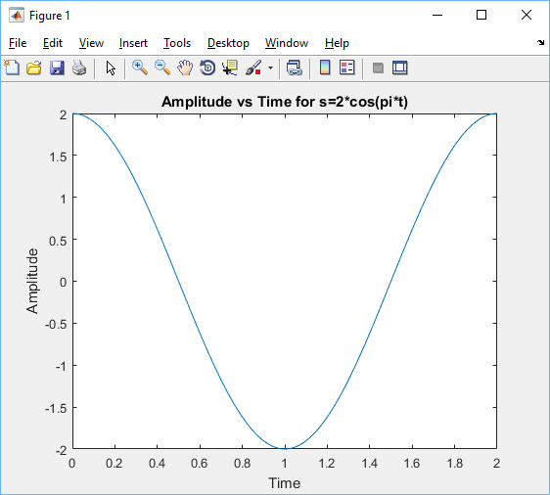

**Figure 4: Time domain for the function s = 2*cos(pi*t)**

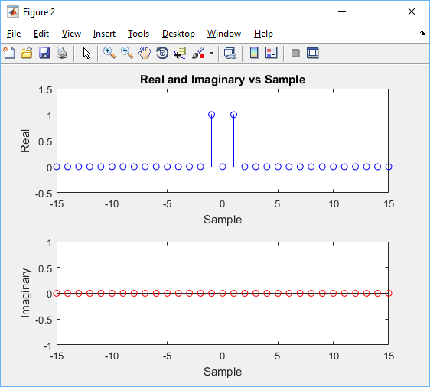

**Figure 5: Frequency domain for the function s= 2*cos(pi*t) real and imaginary vs sample graph.**

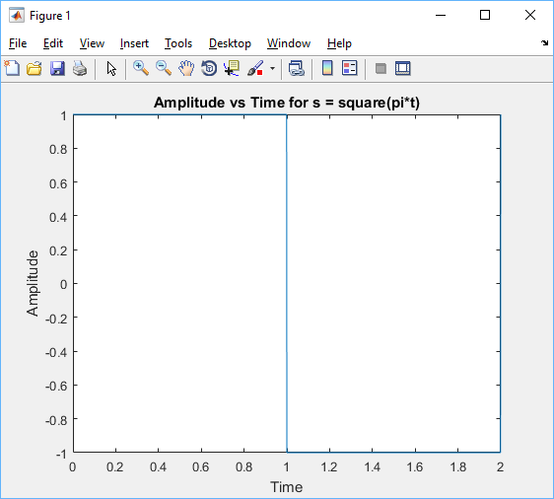

**Figure 6: Time domain for an odd square wave.**

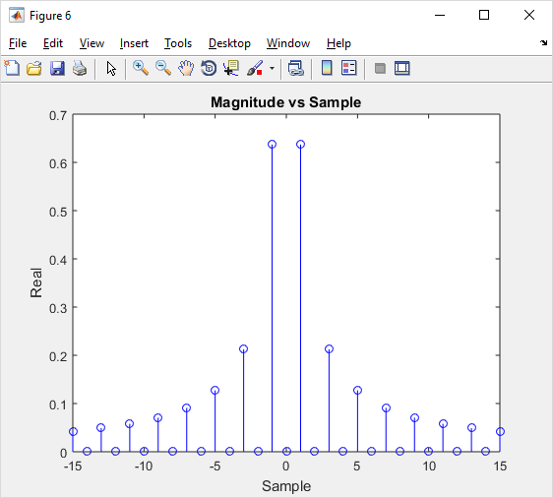

**Figure 7: Frequency domain for an odd square wave of real vs imaginary vs sample.**

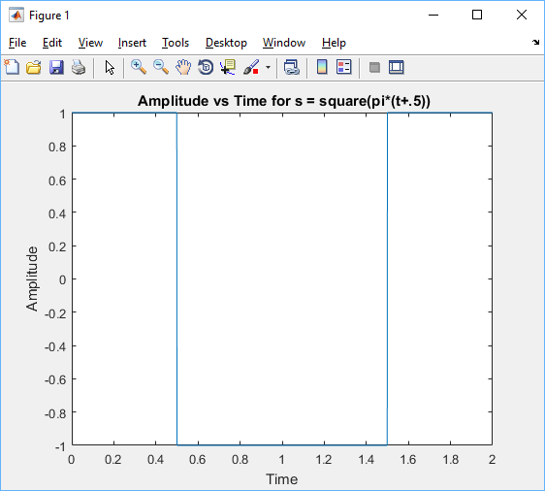

**Figure 8: Time domain for the even square wave.**

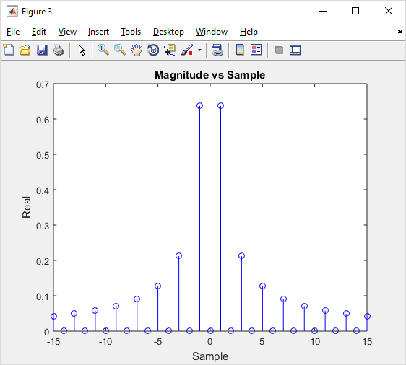

**Figure 9: Frequency domain for even square real and imaginary vs sample.**

**Matlab Code:**

%%

t=0:7;

%Define cosine value

s=2*cos(2*pi*t/4 + pi/3);

% Perform fast fourier transform and shift values

cn=fft(s)/8;

cn=fftshift(cn);

% Create proper sample values to plot against the FFt

n=-4:3;

subplot(2,1,1)

stem(n,abs(cn),'-b');

title('Magnitude and Phase vs Sample for 2cos(2*pi*t/4 +pi/3');

xlabel('Sample');

ylabel('Magnitude');

subplot(2,1,2)

stem(n,angle(cn),'--r');

xlabel('Sample');

ylabel('Phase');

%%

t=0:7;

% Define cosing function

s=cos(2*pi*t/4) +1;

% FFt with proper shifting

cn=fft(s)/8;

cn=fftshift(cn);

n=-4:3;

subplot(2,1,1)

stem(n,abs(cn),'-b');

title('Magnitude and Phase vs Sample for cos(2*pi*t/4)+1');

xlabel('Sample');

ylabel('Magnitude');

subplot(2,1,2)

stem(n,angle(cn),'--r');

xlabel('Sample');

ylabel('Phase');

%%

t=0:7;

% Define function s and perform fft

s=cos(2*pi*t/4) + sin(2*pi*t/8) +1;

cn=fft(s)/8;

cn=fftshift(cn);

n=-4:3;

subplot(2,1,1)

stem(n,abs(cn),'-b');

title('Magnitude and Phase vs Sample for cos(2*pi*t/4 + sin(2*pi*t/8)+1');

xlabel('Sample');

ylabel('Magnitude');

subplot(2,1,2)

stem(n,angle(cn),'--r');

xlabel('Sample');

ylabel('Phase');

%%

t=0:2/2048:2; % Set t value to proper fsampling rate and period of 2 second

s = 2*cos(pi.*t); %Define function s

Figure

plot(t,s)

title('Amplitude vs Time for s=2*cos(pi*t)');

xlabel('Time');

ylabel('Amplitude');

cn = fft(s)/2048;

cn = fftshift(cn);

n = -15:15; % focus on sample points near orgin

cnn = cn(1+(2048/2)+n);

% Plot Real and Imaginary vs Sample

figure

subplot(2,1,1)

stem(n,real(cnn),'-b');

title('Real and Imaginary vs Sample');

xlabel('Sample')

ylabel('Real');

subplot(2,1,2)

stem(n,round(imag(cnn)),'--r');

xlabel('Sample');

ylabel('Imaginary');

%%

t=0:2/2048:2;

% Define square wave

s = square(pi*t)

figure

plot(t,s)

title('Amplitude vs Time for s = square(pi*t)');

xlabel('Time');

ylabel('Amplitude');

cn = fft(s)/2048;

cn = fftshift(cn);

n = -15:15;

cnn = cn(1+(2048/2)+n);

figure

subplot(2,1,1)

stem(n,real(cnn),'-b');

title('Real and Iaginary vs Sample');

xlabel('Sample')

ylabel('Real');

subplot(2,1,2)

stem(n,imag(cnn),'--r');

xlabel('Sample');

ylabel('Imaginary');

%%

t=0:2/2048:2;

% Define odd square wave

s = square(pi*(t+0.5));

figure

plot(t,s)

title(' Amplitude vs Time for s = square(pi*(t+.5))');

xlabel('Time');

ylabel('Amplitude');

cn = fft(s)/2048;

cn = fftshift(cn);

n = -15:15;

cnn = cn(1+(2048/2)+n);

figure

subplot(2,1,1)

stem(n,real(cnn),'-b');

title('Real and Imaginary vs Sample');

xlabel('Sample')

ylabel('Real');

subplot(2,1,2)

stem(n,imag(cnn),'--r');

xlabel('Sample');

ylabel('Imaginary');

**Part 2:**

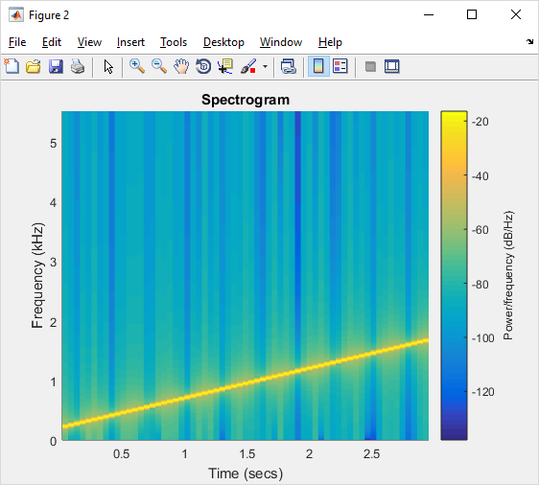

**Figure 10: Spectrogram initial frequency 200Hz final frequency 1700Hz.**

The signal starts out at a very low pitch and gradually increases as time goes on. As the signal increases in frequency the overall volume of the signal starts high, but decreases over time.

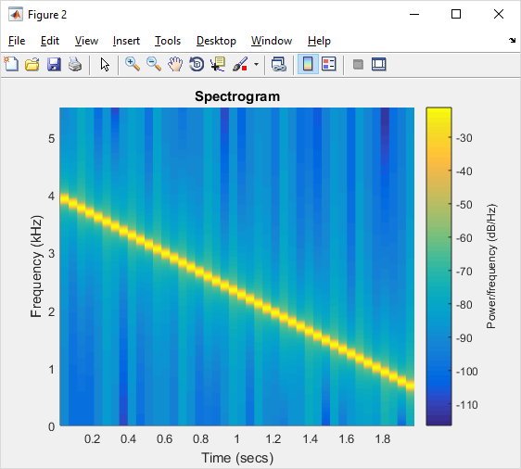

**Figure 11: Spectrogram with initial frequency at 4000 Hz and ending frequency at 600 Hz fsamp: 11025hz.**

The signal starts at a high somewhat quieter pitch and as time goes on the frequency of the signal decreases, but the amplitude slowly increases along with it.

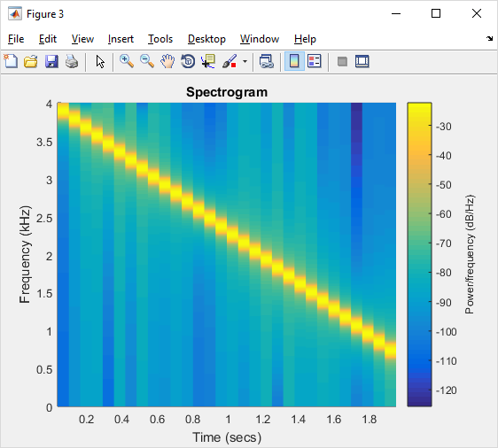

**Figure 12: Spectrogram with initial frequency at 4000 Hz and ending frequency at 600 Hz fsamp: 8000hz.**

This signal is nearly identical to figure 11 in terms of how the frequency starts fairly high and gradually gets lower over time. The amplitude is also similar to the previous signal with a very hard to tell difference in just the sampling rate.

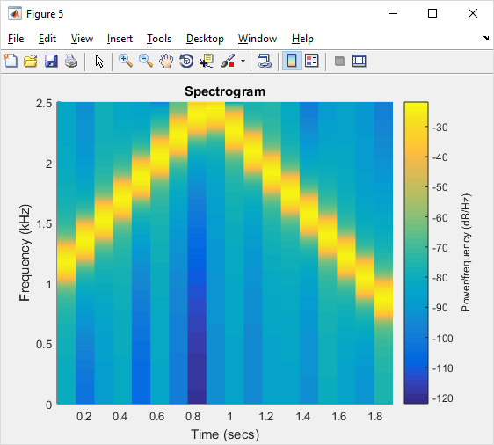

**Figure 13: Spectrogram with initial frequency at 4000 Hz and ending frequency at 600 Hz fsamp: 5000hz.**

This signal, which is supposed to have a similar frequency and amplitude to the previous two signals, sounds completely different. The frequency starts off increasing, then suddenly when reaching .9 seconds suddenly starts decreasing. The amplitude also does not reach as high as the previous signals, with the two having an amplitude of around 4khz, only going up to around 2.5 kHz. This is a clear sign of aliasing, which is caused when not enough sampling points are taken at the correct intervals.

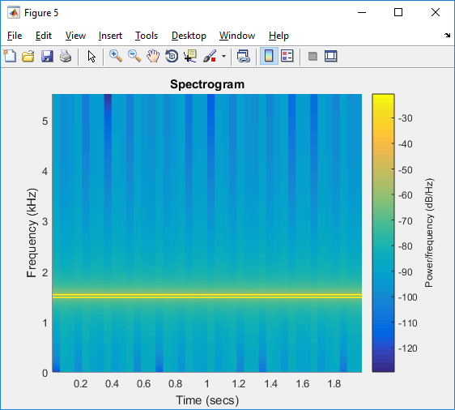

**Figure 14: Spectrogram of a beat signal. Fc = 1500 Hz, fm = 25 hz, fs = 11025 and dur = 2sec.**

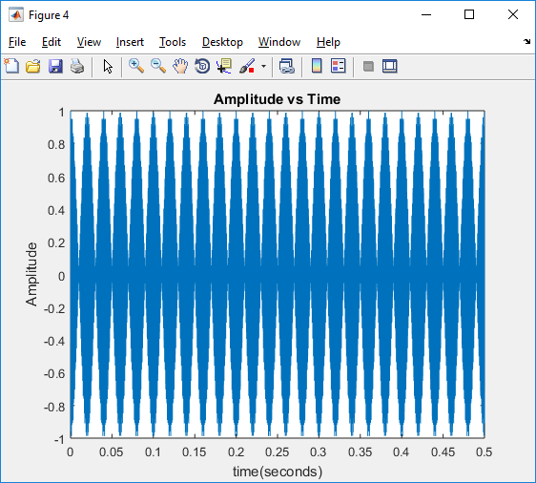

**Figure 15: Amplitude vs Time for a beat signal in 0.5 Seconds.**

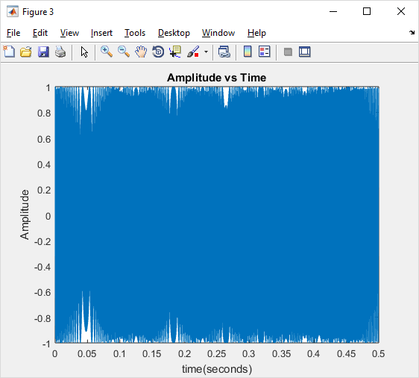

**Figure 16: Amplitude vs Time for chirp signal at .5 seconds. Fsamp = 11025.**

Beat and Chirp are two important signals that are used in everyday life, however there is a clear difference between the two. A beat signals amplitude vs time graph, shows that there is a repetitive pulse that generates in a period. A chirp signal does not have a repetitive pulse or a consistent period, unlike beat.

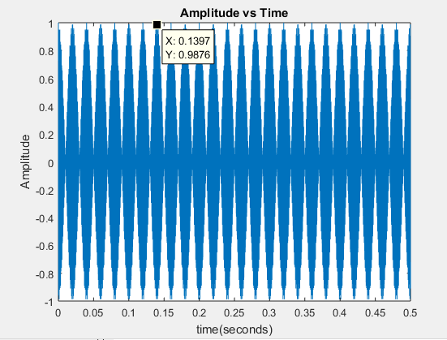

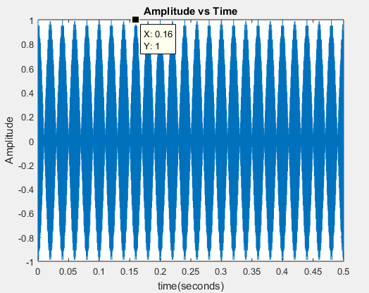

**Figure: 17 and 18: Amplitude vs Time for a beat signal at 0.5 Seconds.**

C. The beat signal is in fact periodic with a period of around .02 seconds.

D. The main difference between chirp and beat in terms of audio is mainly with how the frequency is displayed. In chirp the frequency of the signal will either gradually increase or decrease. A beat signal has a fairly consistent frequency that stays at relatively the same value.

**Matlab Code:**

%% Lab 2 Part 2a.

%% I.

fi = 200;

fend = 1700;

dur = 3;

fsamp = 11025;

[xx,tt] = mychirp(fi,fend,dur,fsamp);

figure

spectrogram(xx,1024,[],1024,fsamp,'yaxis')

title('Spectrogram');

%% II.

fi = 4000;

fend = 600;

dur = 2;

fsamp = 11025;

[xx,tt] = mychirp(fi,fend,dur,fsamp);

figure

spectrogram(xx,1024,[],1024,fsamp,'yaxis')

title('Spectrogram');

%% IId.

fi = 4000;

fend = 600;

dur = 2;

fsamp = 8000;

[xx,tt] = mychirp(fi,fend,dur,fsamp);

figure

spectrogram(xx,1024,[],1024,fsamp,'yaxis')

title('Spectrogram');

%% IIe.

fi = 4000;

fend = 600;

dur = 2;

fsamp = 5000;

[xx,tt] = mychirp(fi,fend,dur,fsamp);

figure

spectrogram(xx,1024,[],1024,fsamp,'yaxis')

title('Spectrogram');

%% Part 2b.

fc = 1500;

fm = 25;

fs = 11025;

dur = .5;

[ xx, tt ] = mybeat( fc,fm, fs, dur );

figure

spectrogram(xx,1024,[],1024,fs,'yaxis')

title('Spectrogram');

**Function:**

function [ xx,tt ] = mychirp(fi,fed,dur,fsamp)

mu = ((fed-fi)/(dur))/2;

tt = 0:1/fsamp:dur

% Because the mu function is just the frequency of the function, 2 and pi need to be %multiplied to the function.

xx = cos(2.*pi.*mu.*(tt.^2) + 2.*pi.*fi.*tt);

figure

plot(tt,xx)

title('Amplitude vs Time');

xlabel('time(seconds)');

ylabel('Amplitude');

% converts the digital signal produced by xx into an analog audible signal.

soundsc(xx,fsamp)

end

function [ xx, tt ] = mybeat( fc,fm, fs, dur )

% Define our t vector from 0 to end of duration.

tt = 0:1/fs:dur;

% Create our beat signal.

xx = cos(2*pi*(fm).*tt).*cos(2*pi*fc.*tt);

% Plot

figure

plot(tt,xx)

title('Amplitude vs Time');

xlabel('time(seconds)');

ylabel('Amplitude');

% Convert a digital signal to and analog audible signal with a sampling frequency of fs.

soundsc(xx,fs)

end

**Part 3:**

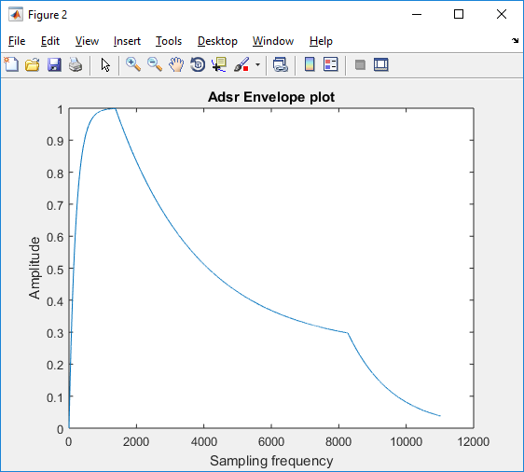

**Figure 19: The Adsr Envelope**

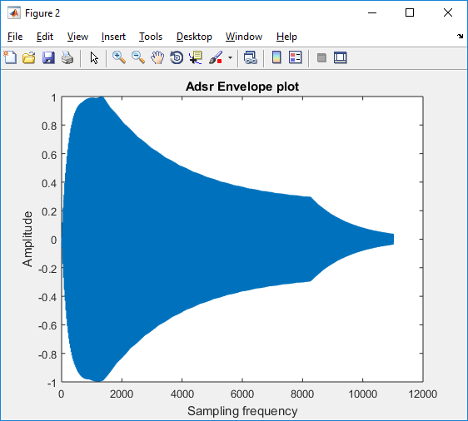

**Figure 20: The Adsr and Cosine of 440 Hz amplitude vs sampling frequency plot.**

The modulate cosine function with the adsr envelope created what sounds like a note. A note that starts off fairly loud with a high pitch and two beats with it, that gradually dissipates as time goes on.

**Matlab Code:**

%% Part 3a

Target = [1-eps;0.25;0]

Gain = [0.005;0.0004;0.00075]

Duration = [125;625;250]

adsr = adsr_gen(Target,Gain,Duration);

plot(adsr);

title('Adsr Envelope plot');

ylabel('Amplitude');

xlabel('Sampling frequency');

%% Part 3b

Target = [1-eps;0.25;0]

Gain = [0.005;0.0004;0.00075]

Duration = [125;625;250]

t = 0:1/11024:1;

% adsr envelope and cosine value

adsr = adsr_gen(Target,Gain,Duration);

second = adsr.*(cos(880*pi.*t'))

figure

plot(adsr)

figure

plot(second);

title('Adsr Envelope plot');

ylabel('Amplitude');

xlabel('Sampling frequency');

soundsc(second,11025)

**Function:**

function a = adsr_gen(target,gain,duration)

% Input

% target - vector of attack, sustain, release target values

% gain - vector of attack, sustain, release gain values

% duration - vector of attack, sustain, release durations in ms

% Output

% a - vector of adsr envelope values

fs = 11025;

a = zeros(fs,1); % assume 1 second duration ADSR envelope

duration = round(duration./1000.*fs) % envelope duration in samp

% Attack phase

start = 2;

stop = duration(1)

for n = [start:stop]

a(n) = target(1)*gain(1) + (1.0 - gain(1))*a(n-1);

end

% Sustain phase

start = stop + 1;

stop = start + duration(2);

for n = [start:stop]

a(n) = target(2)*gain(2) + (1.0 - gain(2))*a(n-1);

end

% Release phase

start = stop + 1

stop = fs;

for n = [start:stop]

a(n) = target(3)*gain(3) + (1.0 - gain(3))*a(n-1);

end;

**Part 4:**

**Case 1:**

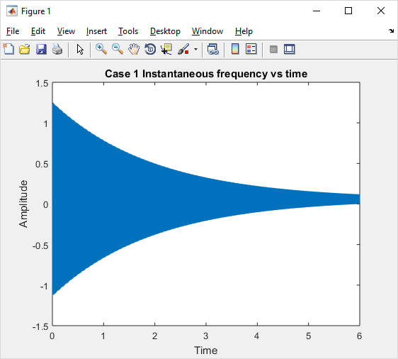

**Figure 21: Case 1 Fi vs time graph.**

B. The fundamental frequency is found to be the greatest common denominator between fc and fm. In Case one of fc at 110 Hz and fm at 220 Hz, the GCD between the two is 110 Hz.

C. As the signal is being played the frequency and amplitude of the signal starts out fairly loud, however over time it gradually decreases and because lower pitch and softer. This is because I(t) at a certain time drops below 4 amps, which causes a suddenly drop in the amplitude of the entire signal.

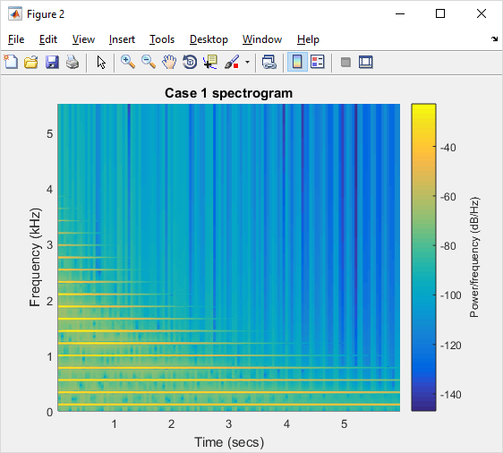

**Figure 22: Case 1 Spectrogram.**

D. The spectrogram of Case one shows a harmonic oscillation as the frequency is increased. At first the time it takes for the signal at the lowest frequency has a lot of power behind it, however as the frequency was increased the overall power of the signal decreased as well. The I(t) value stays about 4 amps up until 0.4527 seconds, after that the frequency of the signal suddenly drops dramatically. The harmonic structure for Case 1 has almost an exponential decay look as frequency increases.

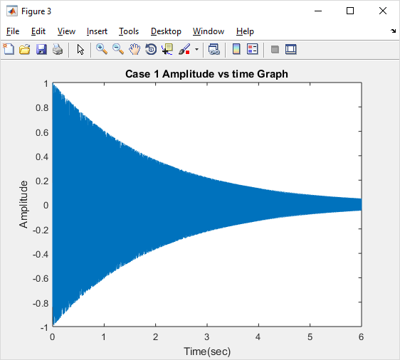

**Figure 23: Case 1 Amplitude vs Time.**

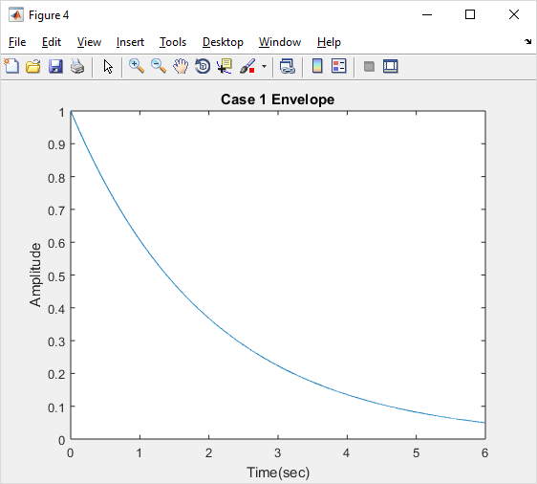

**Figure 24: Case 1 Envelope**

E. Figure 23 shows the entire signal of amplitude vs time and figure 24 shows the signals envelope for case 1. The envelope for case 1 shows only half of the entire signal when compared to figure 23, this is because the actual signal oscillates between a positive and negative amplitude as time goes on.

**Case 3:**

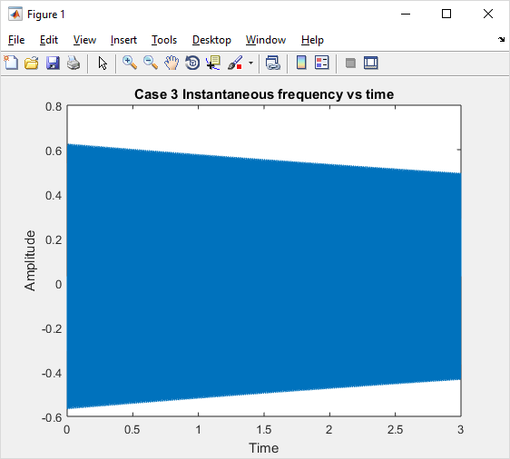

**Figure 25: Case 3 Fi vs time.**

B. The fundamental frequency for Case 3 is 110 Hz. The sound of this signal is very similar to the beginning of Case 1, which also had a fundamental frequency of 110 Hz.

C. The frequency for this signal decreases very slowly over time and suddenly ends before the end of the signal. Because I(t) never drops below 4 Amps, the high frequency of the signal never has a significant drop. This makes it so the signal has a fairly consistent sound to it.

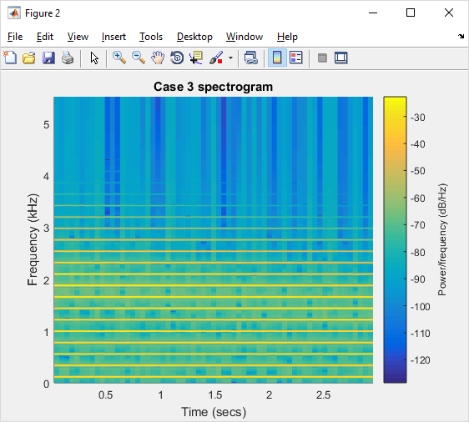

**Figure 26: Case 3 Spectrogram.**

D. The spectrogram for Case 3 shows that the power in the signal stays fairly consistent throughout the frequency increase until passed 3kHz. Because I(t) in this case if fairly high, a more consistent higher frequency is displayed. I(t) never drops below 4 amps throughout the signal until it apruptly ends, this is why the signal stays fairly high-pitched throughout the time frame. The harmonic structure stays relatively the same for the signal with a slight dip in power around the 12 harmonic.

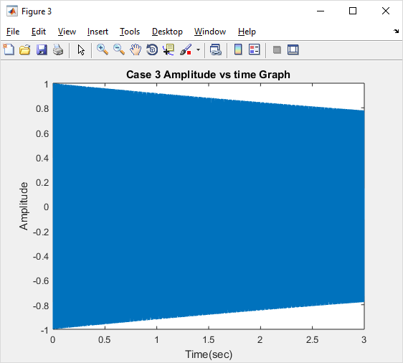

**Figure 27: Case 3 Amplitude vs time.**

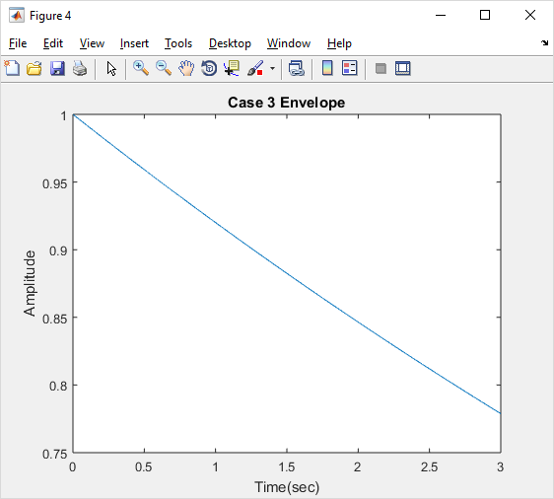

**Figure 28: Case 3 Envelope.**

E. The Case 3 entire signal, figure 27, and the envelope, figure 28, shows that the decrease in amplitude is a linear decline that doesn’t have a suddenly dip at any point, unlike case 1.

**Case 5:**

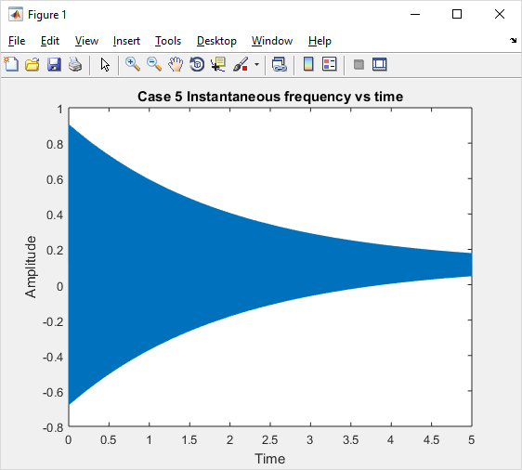

**Figure 29: Case 5 Fi vs Time.**

B. Fc = 250 Hz and Fm = 300 Hz. The fundamental frequency between these two signals is 50 Hz, which can be heard in the signal. The signal has a very low deep tone that is associated with it.

C. Similarly to Case 1, the frequency starts out fairly high and decreases considerably faster than case 3. The I(t) value takes a bit more time to drop off, unlike case 1, however when it does there is an exponential decline over time.

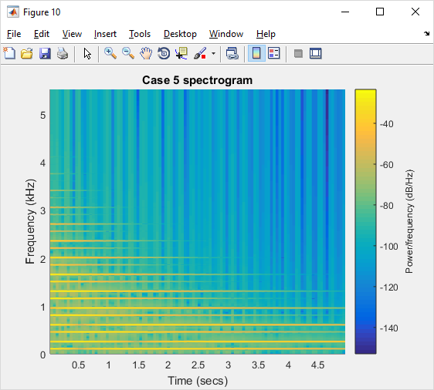

**Figure 30: Case 5 Spectrogram.**

D. At first the power of the signal is fairly stable for the first 3 samples, however after a certain frequency the signals power starts to drop off. This is because when I(t) crosses 4 Amps the signals goes into an exponential decay in terms of amplitude and power. The harmonic structure of the signal starts out fairly similar, but suddenly drops after 4 samples.

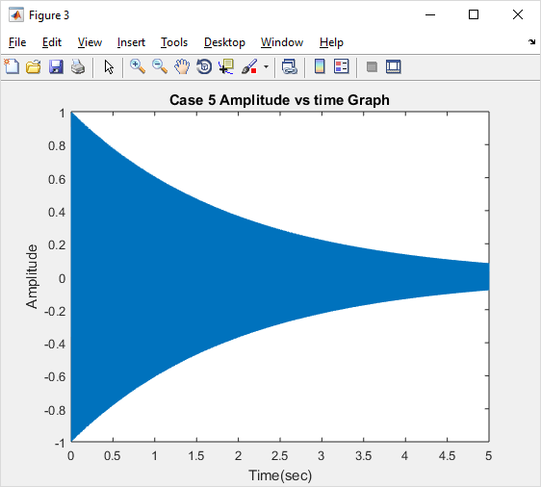

**Figure 31: Case 5 Amplitude vs time.**

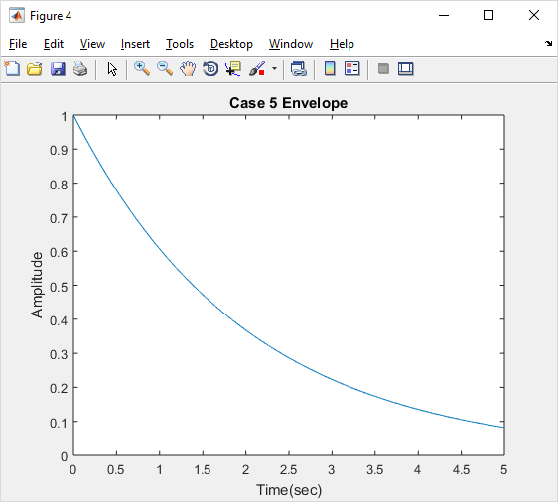

**Figure 32: Case 5 Envelope.**

E. The actual signal, figure 31, and envelope, figure 32, for Case 5 show that around 1 second into the signal an exponential decay starts to happen. It is not as steep as an exponential decay as Case 1, however it is still much steeper than Case 3.

**Matlab:**

%%

ff = [110 220];

Io = 10;

tau = 2;

dur = 6;

fsamp = 11025;

% Perform Bell Function

x = bell(ff,Io,tau,dur,fsamp);

% Create time vector

t = 0:1/fsamp:dur;

soundsc(x,fsamp)

% Find the gcd between the two frequencies.

g = gcd(ff(1),ff(2))

% Find the instantaneous frequency.

I = Io.*bellenv(tau,dur,fsamp);

Id = (Io/tau).*bellenv(tau,dur,fsamp);

fi = ff(1) -I.*ff(2).*sin(2.*pi.*ff(2).*t) - Id.*cos(2.*pi.*ff(2).*t);

figure

plot(t,fi*(dur/fsamp))

title('Case 1 Instantaneous frequency vs time');

xlabel('Time');

ylabel('Amplitude');

figure

spectrogram(x,1024,[],1024,fsamp,'yaxis')

title('Case 1 spectorgram');

figure

plot(t,x)

title('Case 1 Amplitude vs time Graph');

xlabel('Time(sec)');

ylabel('Amplitude');

z = bellenv(tau,dur,fsamp);

figure

plot(t,z);

title('Case 1 Envelope');

xlabel('Time(sec)');

ylabel('Amplitude');

%%

ff = [110 220];

Io = 10;

tau = 12;

dur = 3;

fsamp = 11025;

% Perform Bell Function

x = bell(ff,Io,tau,dur,fsamp);

% Create time vector

t = 0:1./fsamp:dur;

soundsc(x,fsamp)

% Find the gcd between the two frequencies.

g = gcd(ff(1),ff(2))

% Find the instantaneous frequency.

I = Io.*bellenv(tau,dur,fsamp);

Id = (Io/tau).*bellenv(tau,dur,fsamp);

fi = ff(1) -I.*ff(2).*sin(2.*pi.*ff(2).*t) - Id.*cos(2.*pi.*ff(2).*t);

figure

plot(t,fi*(dur/fsamp))

title('Case 3 Instantaneous frequency vs time');

xlabel('Time');

ylabel('Amplitude');

figure

spectrogram(x,1024,[],1024,fsamp,'yaxis')

title('Case 3 spectorgram');

figure

plot(t,x)

title('Case 3 Amplitude vs time Graph');

xlabel('Time(sec)');

ylabel('Amplitude');

z = bellenv(tau,dur,fsamp);

figure

plot(t,z);

title('Case 3 Envelope');

xlabel('Time(sec)');

ylabel('Amplitude');

%%

ff = [250 350];

Io = 5;

tau = 2;

dur = 5;

fsamp = 11025;

% Perform Bell Function

x = bell(ff,Io,tau,dur,fsamp);

% Create time vector

t = 0:1/fsamp:dur;

soundsc(x,fsamp)

% Find the gcd between the two frequencies.

g = gcd(ff(1),ff(2))

% Find the instantaneous frequency.

I = Io.*bellenv(tau,dur,fsamp);

Id = (Io/tau).*bellenv(tau,dur,fsamp);

fi = ff(1) -I.*ff(2).*sin(2.*pi.*ff(2).*t) - Id.*cos(2.*pi.*ff(2).*t);

figure

plot(t,fi*(dur/fsamp))

title('Case 5 Instantaneous frequency vs time');

xlabel('Time');

ylabel('Amplitude');

figure

spectrogram(x,1024,[],1024,fsamp,'yaxis')

title('Case 5 spectorgram');

figure

plot(t,x)

title('Case 5 Amplitude vs time Graph');

xlabel('Time(sec)');

ylabel('Amplitude');

z = bellenv(tau,dur,fsamp);

figure

plot(t,z);

title('Case 5 Envelope');

xlabel('Time(sec)');

ylabel('Amplitude');

**Function:**

function xx = bell(ff,Io,tau,dur,fsamp)

A = bellenv(tau,dur,fsamp);

I= Io.*bellenv(tau,dur,fsamp);

t = 0:1/fsamp:dur;

xx = A.*cos(2.*pi.*ff(1).*t + I.*cos(2.*pi.*ff(2).*t));

end

function yy = bellenv(tau, dur, fsamp);

t= 0:1/fsamp:dur;

yy=exp(-t./tau);

end